Protocol # | Description | Purpose | Reqt/Spec | Author
 | Logout on inactivity | To verify a user is automatically logged out of the web interface when inactive for a set period of time |  | Saurabh Pawar

Prerequisites | - Standard System Configuration.  - The user must be logged in to the Web Interface.  - The timeout period is set in backend database for the Web Interface.  - Inactivity warning is set in the backend database for the Web Interface, for X minutes before timeout.  Note: If timeout settings are changed, allow up to 1 day for the latest configured settings to take effect.
Procedure | - Login with the test user and do not perform any activity in the web interface. Wait for x min.  ER 1 – An inactivity warning is displayed for X minutes before the timeout period.  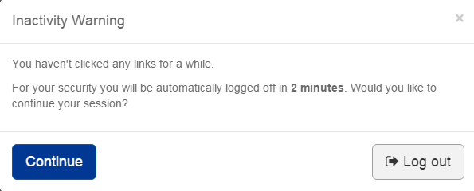  - Continue to remain inactive for the remaining time.  ER 2 – The user is automatically logged out .    - Click on the “Click here” link available  ER 3 – The user is returned to the sign in page .    - Again login with the test user and do not perform any activity in the web interface. Wait for x min  - An inactivity warning is displayed.  - Click on logout.  ER 4 – The user is returned to the sign in page .  - Again login with the test user  - Go to any page.(for eg.My doc)  - Do not perform any activity in the web interface. Wait for x min.  ER 5 – An inactivity warning is displayed.  - Click on Continue.  ER 6 – The user remains active and returned to my doc page .  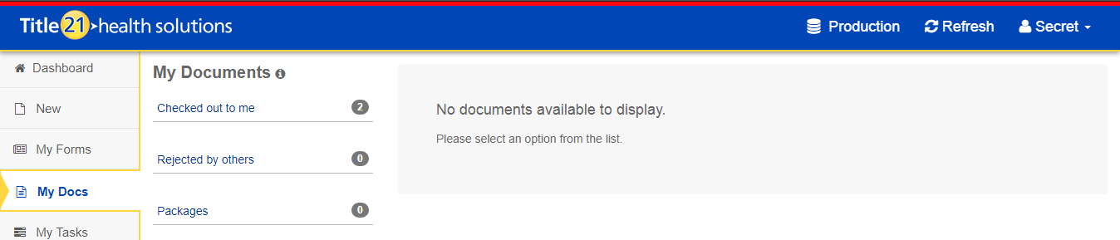
Pass/Fail | Pass:  Fail: | Type of Execution:
Pass/Fail | Pass:  Fail: | Automation: | Manual:
 | Date of Execution:
Signature of  Reviewer/Approver: |  |  |  | Date of Approval:

